Практическая работа №5

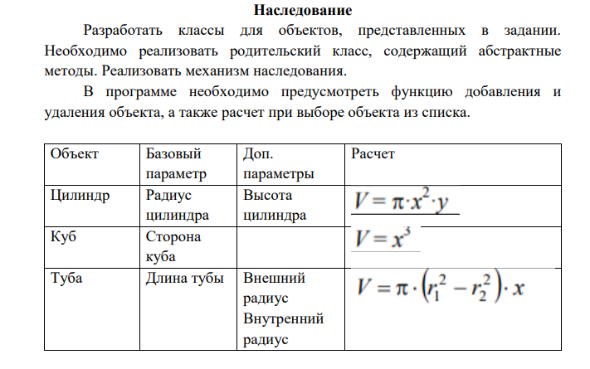

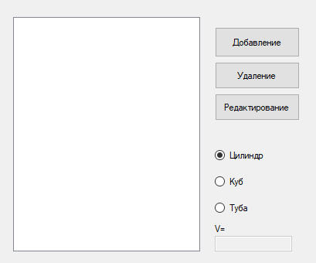

Цилиндр

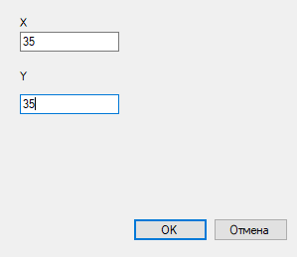

Куб

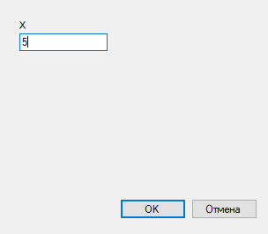

Туба

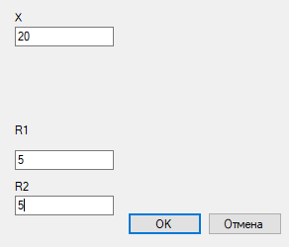

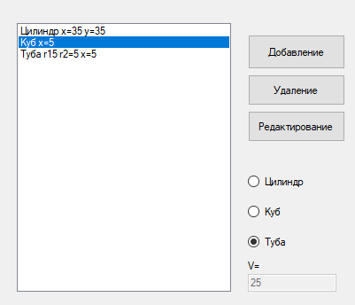

Удаление

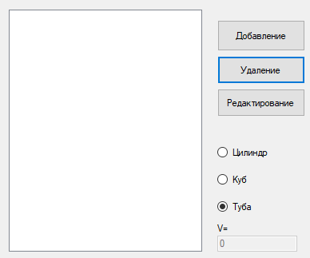

Parents.cs

abstract class Parents

{

public double x;

public Parents(double new_x)

{

x = new_x;

}

abstract public double S();

}

Cl.cs

class Cl : Parents

{

public double y;

public Cl(double new_x, double new_y) : base(new_x)

{

y = new_y;

}

public override double S()

{

double s = Math.PI * Math.Pow(x, 2) * y;

return s;

}

public override string ToString()

{

return "Цилиндр x=" + x+" y="+y;

}

}

Cube.cs

class Сube:Parents

{

public Сube(double new_x) : base(new_x) { }

public override double S()

{

double s = Math.Pow(x, 2);

return s;

}

public override string ToString()

{

return "Куб x=" + x;

}

}

Tuba.cs

class Tuba:Parents

{

public double r1;

public double r2;

public Tuba(double new_x, double new_r1, double new_r2) : base(new_x)

{

r1 = new_r1;

r2 = new_r1;

}

public override double S()

{

double s = Math.PI * ((r1 * r1) - (r2 * r2)) * x;

return s;

}

public override string ToString()

{

return "Туба r1" + r1 + " r2=" + r2+" x="+x;

}

}

Form1.cs

public partial class Form1 : Form

{

public Form1()

{

InitializeComponent();

}

private void button1_Click(object sender, EventArgs e)

{

Form2 f = new Form2();

if (radioButton1.Checked)

{

//Цилиндр

f.Text = "Добавление цилиндра";

f.textBox3.Visible = false;

f.label3.Visible = false;

f.textBox4.Visible = false;

f.label4.Visible = false;

if (f.ShowDialog() == DialogResult.OK)

{

double x = Convert.ToDouble(f.textBox1.Text);

double y = Convert.ToDouble(f.textBox2.Text);

Cl r = new Cl(x, y);

listBox1.Items.Add(r);

}

}

else if (radioButton2.Checked)

{

f.Text = "Куб";

f.textBox2.Visible = false;

f.label2.Visible = false;

f.textBox3.Visible = false;

f.label3.Visible = false;

f.textBox4.Visible = false;

f.label4.Visible = false;

if (f.ShowDialog() == DialogResult.OK)

{

double x = Convert.ToDouble(f.textBox1.Text);

Сube cu = new Сube(x);

listBox1.Items.Add(cu);

}

}

else

{

f.Text = "Добавление тубы";

f.textBox2.Visible = false;

f.label2.Visible = false;

if (f.ShowDialog() == DialogResult.OK)

{

double r1 = Convert.ToDouble(f.textBox3.Text);

double r2 = Convert.ToDouble(f.textBox4.Text);

double x = Convert.ToDouble(f.textBox1.Text);

Tuba tu = new Tuba(r1,r2,x);

listBox1.Items.Add(tu);

}

}

}

private void listBox1_SelectedIndexChanged(object sender, EventArgs e)

{

if (listBox1.SelectedIndex != -1)

{

Parents p = listBox1.Items[listBox1.SelectedIndex] as Parents;

textBox1.Text = p.S().ToString();

}

}

private void button2_Click(object sender, EventArgs e)

{

if (listBox1.SelectedIndex == -1)

{

MessageBox.Show("Объект не выбран");

}

else

{

listBox1.Items.RemoveAt(listBox1.SelectedIndex);

}

}

}

Ссылка на гитхаб:

<https://github.com/Alexandrov911/PR5.2022.git>